07/11/22
THM 415: Finance
Midterm Exam Answer Sheet
- Why should the Balance Sheet balances? (2 Points)
Since assets shall be owned by companies through purchasing them and since there are merely 2 ways of financing those very purchases (either through acquiring debt-i.e. Liabilities or issuing equity – i.e. Owners’ Equity), it implies that assets (on the left-hand side of the balance sheet) shall be equal to liabilities and owners’ equity (on the right-hand side of the balance sheet). Hence, the balance sheet balances.
- Redmond Hotel had recorded the following income statement accounts sorted in alphabetical order:
Cost of Goods Sold | $2,043,569
Interest Expenses | $254,041
Operating Expenses | $873,387
Sales | $4,023,692
In addition, since Redmond Hotel owns 62 % shares of Nathan Company, it is entitled to $ 1,903,501 of dividends income from that very company. Moreover, Redmond hotel’s board of directors decided to distribute $ 140,750 as dividends to their shareholders.
The following table reveals Income Tax Rates for Corporate Income for 2021 fiscal year:
Lastly, the following table shows dividend income exclusion to avoid double taxation at corporate level.
a) Construct Redmond Hotel Income Statement for the year ended December 31st, 2021. (2 Points)

Moreover, the following is Redmond Hotel’s comparative balance sheet as of December 31st, 2020 and December 31st, 2021:
- Construct Redmond Hotel Statement of Cash Flow for the year ended December 31st, 2021. (3 Points)
- Calculate the Quality of Earnings. Interpret your result. (1 Point)
- Quality of Earnings = (Cash Flow from Operations) / (Net Income) = 448,120 / 519,708 = 86.23 %.
Thus, in 2021, Redmond Hotel’s cash flow from operations was 86.23 % of the firm’s reported net income.
- Calculate the Capital Acquisition Ratio. Interpret your result. (1 Point)
- Capital Acquisition Ratio = (Cash Flow from Operations) / (Cash Paid for Capital Expenditures) = 448,120 / 113,123 = 396.14 %.
Thus, in 2021, Redmond Hotel was able to finance 396.14 % of its new expenditures for plant and equipment out of the firm’s operation’s cash flow.
- Based on the income statement prepared in part a), comparative balance sheet and cash flow statement prepared in part b), analyze the financial situation of Redmond Hotel for the fiscal year 2021. (3 Points)
Income Statement:
- In 2021, Redmond hotel is a profitable company as its revenues (i.e. sales) are greater than its costs.
- In 2021, Redmond Hotel’s mark-up on its cost of goods sold is 49.21 %.
- In 2021, for each dollar of revenue, Redmond Hotel is left with 27.51 cents after deducting all its operating expenses.
- In 2021, each one dollar of sales is associated with 12.92 cents of net income.
Balance Sheet:
- Redmond hotel is a highly liquid company as its net working capital is $ 1,028,542. This means that current assets can shrink by as much as $ 1,028,542 and the company would still be able to pay its current liabilities.
- In Redmond Hotel, the purchases of assets are financed 49.23 % through debt and 50.77 % through equity.
- For each one dollar of net income, 72.92 cents are retained in the business.
Statement of Cash Flow:
Cash flow from operating activities:
- Redmond Hotel has positive cash flows from operating activities.
- The primary contributor to the operating cash flows was net income.
- Inventories, other current assets, accounts payable and accrued expenses are contributors of cash usage.
Cash flow from investing activities:
- Redmond Hotel has a positive cash flow from investing activities.
- Redmond Hotel sold $ 113,019 of its fixed assets generating an equal amount of cash inflow.
Cash flow from financing activities:
- Redmond Hotel has negative cash flows from financing activities.
- Cash usage resulted from payment of already declared dividends, purchase of marketable securities as well as decrease in common stock (paid-in capital).
- The contributors to cash were the issuance common stock, getting a short-term note, and obtaining a long-term note.
- Suppose you would like to double your investment. For this purpose, you deposited in a bank $ 20,237.19 to be compounded each 2 months at an interest rate of 3.14 %. Calculate the period (in years) needed to reach your objective? (1 Point)
- Interest Rate = 3.14 % / 6 ≈ 0.52 %; Present Value = - $ 20,237.19; Payment = $0; Future Value = $ 40,474.38.
Answer: Nper (0.52 %, 0, -20237.19, 40474.38) / 6 = 22.13 Years.
Therefore, it would take 22.13 years for an investment of $ 20,237.19 to double at an annual interest rate of 3.14 % compounded each 2 months.
- After examining the various interest rates opportunities, you find that you can invest in a finance company at 12.08 % compounded weekly, in bank A at 12.25 % compounded quarterly.
a) Which alternative is the most attractive? Why? (1 Point)
- Investing in Finance Company: Effective Annual Rate= Effect (12.08 %, 52) = 12.82 %.
- Investing in bank A: Effective Annual Rate = Effect (12.25 %, 4) = 12.82 %.
Since I am investing, I shall choose the offer that has the highest Effective Annual Rate. Therefore, I shall invest in Bank A (12.8243 % for Bank A vs. 12.8241 % for Finance Company).
b) If you wanted to consider Bank B which offers continuous compounding. What is the minimum interest rate suggested by this very bank to start thinking about the offer? (1 Point)
Bank B shall give me a minimum annual rate of 12.07 % to start thinking about the offer.
- Muleka wanted to buy a home that costs $ 250,853. He took a 10-year mortgage loan with semi-annual payments at an annual rate of 4.15 %.
a) How much will Muleka pay each period? (1 Point)
Interest = 4.15 % / 2 = 2.075 %, Period = 10 * 2 = 20; Present Value = $ 250,853; Future Value = $ 0
Answer: Payment (2.075 %, 20, 250853, 0) = $ - 15,452.61.
b) Fill in the amortization schedule. (3 Points)
Period | Amount Owed on the Principal (Beg. Period) ($) | Annuity Payment ($) | Interest Portion of the Annuity ($) | Repayment of the Principal Portion of the Annuity ($) | Outstanding Loan Balance ($)
1 | $250,853.00 | $15,452.61 | $5,205.20 | $10,247.41 | $240,605.59
2 | $240,605.59 | $15,452.61 | $4,992.57 | $10,460.04 | $230,145.55
3 | $230,145.55 | $15,452.61 | $4,775.52 | $10,677.09 | $219,468.47
4 | $219,468.47 | $15,452.61 | $4,553.97 | $10,898.64 | $208,569.83
5 | $208,569.83 | $15,452.61 | $4,327.82 | $11,124.78 | $197,445.05
6 | $197,445.05 | $15,452.61 | $4,096.98 | $11,355.62 | $186,089.43
7 | $186,089.43 | $15,452.61 | $3,861.36 | $11,591.25 | $174,498.18
8 | $174,498.18 | $15,452.61 | $3,620.84 | $11,831.77 | $162,666.41
9 | $162,666.41 | $15,452.61 | $3,375.33 | $12,077.28 | $150,589.13
10 | $150,589.13 | $15,452.61 | $3,124.72 | $12,327.88 | $138,261.25
11 | $138,261.25 | $15,452.61 | $2,868.92 | $12,583.69 | $125,677.56
12 | $125,677.56 | $15,452.61 | $2,607.81 | $12,844.80 | $112,832.76
13 | $112,832.76 | $15,452.61 | $2,341.28 | $13,111.33 | $99,721.44
14 | $99,721.44 | $15,452.61 | $2,069.22 | $13,383.39 | $86,338.05
15 | $86,338.05 | $15,452.61 | $1,791.51 | $13,661.09 | $72,676.96
16 | $72,676.96 | $15,452.61 | $1,508.05 | $13,944.56 | $58,732.40
17 | $58,732.40 | $15,452.61 | $1,218.70 | $14,233.91 | $44,498.49
18 | $44,498.49 | $15,452.61 | $923.34 | $14,529.26 | $29,969.23
19 | $29,969.23 | $15,452.61 | $621.86 | $14,830.74 | $15,138.48
20 | $15,138.48 | $15,452.61 | $314.12 | $15,138.48 | $0.00
c) Suppose that exactly after 6 years, mortgage interest rates fell to 3.14 %. If Muleka has the chance to refinance his loan at that very interest, how much would he pay (on a semi-annual basis) for the remaining 4 years of the loan? (1 Point)
- Interest = 3.14 % / 2 = 1.57 %, Period = 4 * 2 = 8; Present Value = $ 112,832.76; Future Value = $ 0
Answer: Payment (1.57 %, 8, 112832.76, 0) = $ - 15,118.66.
d) If such a refinance opportunity is associated with paying a prepayment penalty fee to the bank of $ 2,500, shall Muleka refinance his loan? Why? Why not? (2 Points)
The answer to this question lies in coming up with cash flow increments by taking the difference of cash flows (for each of the remaining 4 years) between the first scenario (i.e. continuing paying $ 15,452.61) and second scenario (i.e. paying $ 3,080 as a penalty in year 0, and start saving $ 333.95 for the remaining 8 six-month period). To sum up, the following table reveals the cash flow increments from opting for the second scenario:

As can be seen from the above table, paying $ 2,500 as a pre-payment penalty but start saving $ 333.95 for the remaining 8 six-month period (i.e. 15,452.61 – 15,118.66) would yield a negative return. Hence, Muleka shall not re-finance the mortgage loan since he will be worse off when opting for the second scenario.
- Upon evaluation of the distribution of returns of Destanoğlu company, the following possible rate of returns for the upcoming period as long as their probability of occurrence are estimated:
Probability of Occurrence | Rate of Return on Investment
6% | -8.57%
11% | -4.36%
16% | -2.05%
21% | 2.78%
19% | 5.41%
17% | 9.03%
10% | 12.12%
a) Calculate the Expected Rate of Return of Destanoğlu Company stock. (1 Point)
- Expected Rate of Return = (6 % * - 8.57 %) + (11 % * - 4.36 %) + (16 % * - 2.05 %) + (21 % * 2.78 %) + (19 % * 5.41 %) + (17 % * 9.03 %) + (10 % * 12.12 %) = 3.04 %.
b) What is the risk of the investment in Destanoğlu Company stock as measured using the standard deviation of possible future rates of return? (2 Points)
- Nathan bought some stocks of Redmond Company worth of 1,250,000 Yens 9 years ago. Following is the beginning value of Redmond bought stocks 9 years ago as well as the values at the end of each year up until today (the end of year 9):
Year | Stock Value (Yens)
0 | 1,250,000.00
1 | 1,210,750.00
2 | 1,183,629.20
3 | 1,232,749.81
4 | 1,262,705.63
5 | 1,286,191.96
6 | 1,326,578.38
7 | 1,372,743.31
8 | 1,441,517.75
9 | 1,422,633.87
a) What will be the annual rate of return that Nathan expects to earn next year, if he plans to continue holding Redmond Company stocks? (1 Point)
- Annual rate of return that Nathan expects to earn next year, if he plans to continue holding Redmond Company stocks = (- 3.14 % - 2.24 % + 4.15 % + 2.43 % + 1.86 % + 3.14 % + 3.48 % + 5.01% - 1.31 %) / 9 = 1.49 %.
b) What annual rate of return that Nathan expects over a five-year horizon from holding Redmond Company stocks? (1 Point)
- Annual rate of return that Nathan expects over a five-year horizon from holding Redmond Company stocks = ((1 + 1.86 %) * (1 + 3.14 %) * (1 + 3.48 %) * (1 + 5.01 %) * (1 - 1.31 %)^^{(1/5)}) – 1) = 2.41 %.
- You own a portfolio consisting of the following stocks:
Assume the risk-free rate is 4.53 % and the expected return on the market portfolio is 20.58 %.
- Calculate the expected return of your portfolio. (0.50 Points)
- Expected return (Portfolio) = (16 % * 17.99 %) + (35 % * 12.53 %) + (22 % * 22.06 %) + (12 % * 17.75 %) + (15 % * 20.83 %) = 17.37 %.
- Calculate the portfolio beta. (0.50 Points)
- Beta (Portfolio) = (16 % * 0.84) + (35 % * 0.63) + (22 % * 1.25) + (12 % * 0.93) + (15 % * 1.05) = 0.90.
- Plot the security market line on a graph. (2 Points)
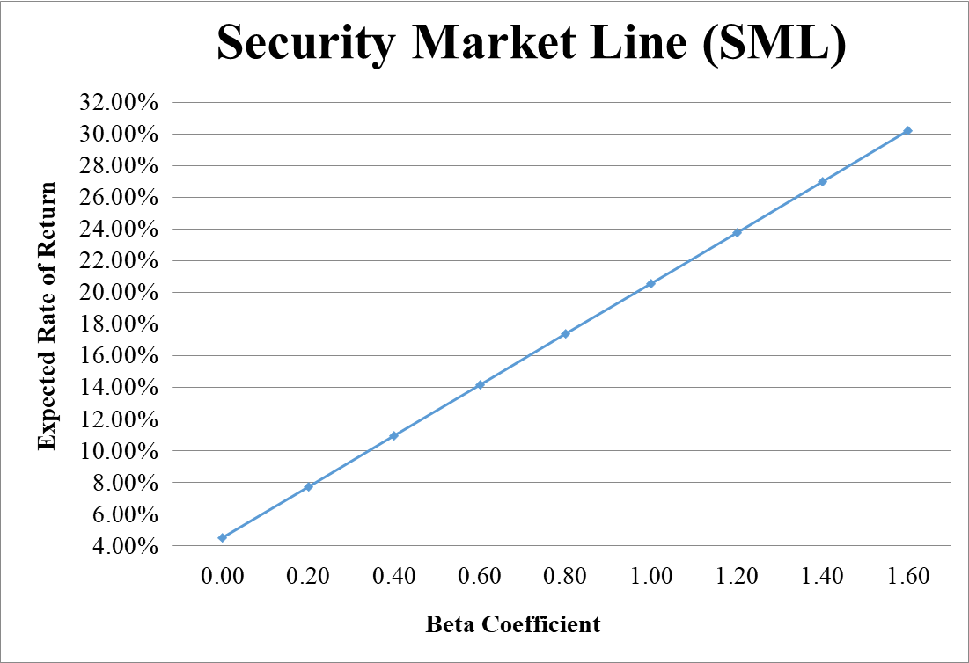
- From your plot in part c, which stocks appear to be your winners, and which ones appear to be losers? Explain the reason behind your conclusion. (2 Points)
- If Expected Return < SML Expected Return → Loser, otherwise Winner.
- Why should you consider your conclusion in part d) to be less than certain? (1 Point)
This conclusion is based on our having the right betas. Recall that calculation of Betas are subjective (i.e. depend on the market to be chosen, sample size, time interval chosen, definition of period…). If all of our betas understate their stock’s systematic risks, then we would be underestimating our portfolio risk.
GOOD LUCK!

